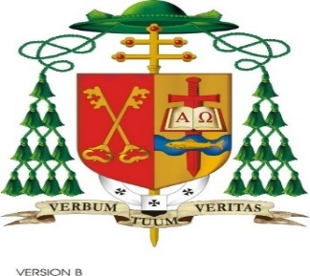
Christmas 2021
Dear Friends in Christ,
I take this opportunity to wish you and your families the peace and joy that the birth of Jesus, our Saviour, brings to our world. Remembering in a special way those who cannot be at the Christmas table this year.
Christmas is surely the most joyful time of the year when the sparkle in the eyes of children lights up our lives. However, as we are all too well aware, our celebrations this year are, like last Christmas, being held under the shadow of the Covid-19 pandemic. The virus continues to impact seriously on our lives and the lives of countless millions around the world.
The birth of the infant called Emmanuel – “God is with Us” announcers a new beginning and a new era for all humanity and calls us to identify our common humanity with our sisters and brothers throughout the world. This pandemic has brought us to a keen awareness of how inter-connected our world is. The reality of the pandemic, now in a very practical way, calls on us to demand and to raise our voices for equity in the distribution of vaccines for all - as no one is safe unless we are all safe!
This Christmas I invite you to bring to your thoughts and prayers our missionaries from our diocese and from Ireland - the women and men working in different corners of the world to bring the Christmas message of Peace and Love especially in those areas where the pandemic is at its most virulent.
As 2021 draws to a close we are thankful that, throughout these challenging times, light has been shining out in countless examples of love and kindness. Communities have witnessed an outpouring of goodness, generosity and courage from neighbours, volunteers, doctors, nurses, priests, chaplains, carers and so many others who have devoted themselves to keeping our essential services going, on all our behalf, I say, Mile Buíochas.
Our thoughts and prayers this Christmas are also with those who are struggling to cope with the pain of loneliness, bereavement, suffering, grief and loss of employment. May we reach out to a neighbour or family member who would appreciate our friendship at this time.
The central message for people of faith in every generation is summed up in the name given to the Messiah in the Book of the Prophet Isaiah – Emmanuel “God is with us”. Through the birth of the infant Jesus we are assured of God’s abiding presence with us. May the name of the infant Messiah be a comfort and strength to us all in these times.

Cherish and enjoy these days of being together with family, friends and neighbours.
May 2022 be a year of blessings for all of us.
Le gach dea-ghuí I gcomhair na Nollag agus na hAthbhliana, 2022.
+ Kieran

